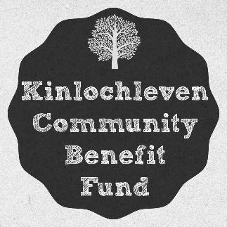
Membership Application
Kinlochleven Community Benefit Fund
(SCIO SC049946)
First Name: | Surname:
Address:
Address:
Address:
Post Code:
Contact Number:
Email:

Membership Applied For: FULL
Full Membership is retained continuously whilst an individual meets all the membership criteria below, or until they cancel their membership.

Preferred Contact Method: (tick all that apply)
Email | Telephone | Post

Membership Criteria
Please confirm that you qualify for each of the following criteria making you eligible for membership:
Aged 16, or over
Ordinarily resident within the Kinlochleven Community Council Area
Registered to vote within the Kinlochleven Community Council Area
Support the purposes of the Kinlochleven Community Benefit Fund

Membership Confirmation
I confirm that I am applying for membership to the Kinlochleven Community Benefit Fund (SC049946) according to the membership criteria above and will comply with the Kinlochleven Community Benefit Fund (SCIO) Constitution.
Signature:

Date:

Please email completed forms to info@kcbf.co.uk

